Our figma code

https://www.figma.com/proto/aMR3m97lEXlKuce2bBSP8c/website?node-id=3-49&t=X0LkjBHPrx98uHL9-1

Project Report – University Club Hub Website

Course: DMSE

Student: Relebohile duma 901019375

Rabohlale Mojakisane 901019513

Mohloai Qamo 901019200

Kamohelo Chele 901019387

Litshoanelo Motsekoa 901019460

Reitumetse Nooe 901018647

1. Introduction

The University Club Hub project was developed as a centralized platform to showcase student clubs, upcoming events, and provide a contact channel for inquiries. The project integrates HTML5, CSS3, JavaScript, and Figma prototypes, aligning with the assignment requirements for structure, interactivity, responsiveness, and design documentation.

2. Project Components

2.1 HTML Pages

Five fully developed pages were created:

1. Home (index.html)

• Introduces the platform and highlights featured clubs/events.

• Includes a call‑to‑action button linking to the Events page.

2. About (about.html)

• Outlines the mission and vision of the platform.

• Emphasizes inclusivity, accessibility, and student empowerment.

3. Clubs (clubs.html)

• Displays clubs in a grid layout using semantic and tags.

• Each club card includes a description and hover effect.

4. Events (events.html)

• Features a dynamic slideshow carousel with navigation arrows and indicators.

• Auto‑plays every 5 seconds, with manual navigation enabled.

5. Contact (contacts.html)

• Provides a contact form with validation (required fields, email format).

• Includes a styled message box for feedback and an address block for office details.

2.2 CSS Styling (style.css)

• Theme Variables: Defined in for consistent colors, fonts, and backgrounds.

• Navigation: Sticky header with hover/active states and smooth transitions.

• Layout: styled as card‑like sections with shadows and rounded corners.

• Forms: Inputs styled with focus states, consistent padding, and accessible labels.

• Slideshow: Styled container with arrows, indicators, and responsive scaling.

• Responsive Design: Media queries for tablets and mobile ensure adaptability.

2.3 JavaScript Files

1. Form Validation (script.js)

• Validates required fields and email format.

• Displays styled success/error messages in a floating message box.

• Resets the form after successful submission.

• Optional “submitting” state can simulate Figma prototype flow.

2. Slideshow (events.js)

• Cycles through event slides automatically every 5 seconds.

• Supports manual navigation via arrows and indicators.

• Resets timer on manual interaction for better UX.

2.4 Figma Prototypes

• Contact Form States:

• Empty → Filled → Error → Submitting → Success.

• Simulates realistic form submission flow.

• Event Carousel:

• Three slides (Tech Club Hackathon, Drama Club Performance, Sports Day Tournament).

• Manual navigation with arrows and auto‑play transitions.

These prototypes guided the HTML/CSS/JS implementation, ensuring design consistency.

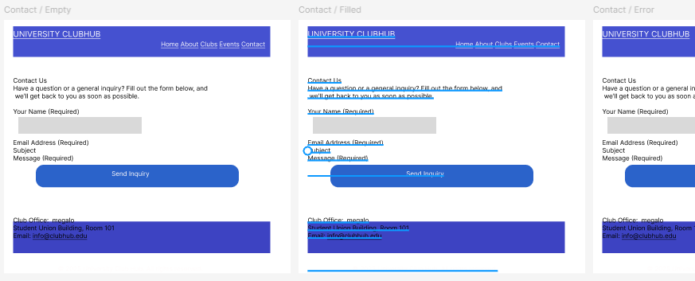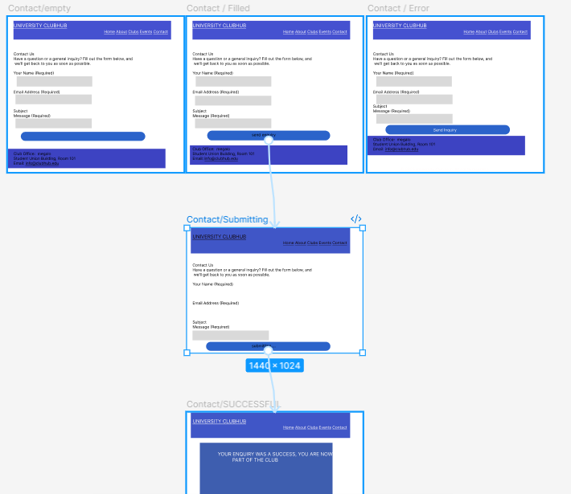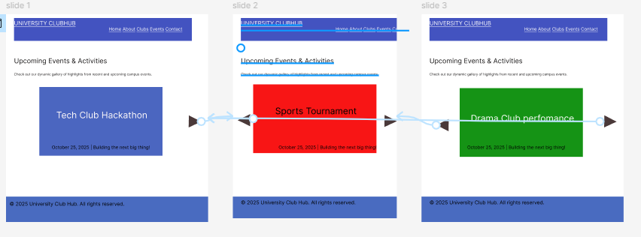

3. Problems Encountered & Solutions

• Problem: Confusion about simulating typing in the form.

• Solution: Used Empty and Filled frames in Figma, then mirrored with HTML/JS validation.

• Problem: Initially edited the “Send Inquiry” button directly instead of creating a Submitting state.

• Solution: Duplicated frames and implemented a Submitting → Success flow.

• Problem: Unsure how to place and wire arrows in the carousel.

• Solution: Positioned arrows at frame edges, wired them in Figma, and implemented with JS.

• Problem: Email regex too restrictive.

• Solution: Updated regex to allow longer domain extensions.

4. Alignment with Assignment Rubric

5. Conclusion

The University Club Hub project successfully delivers a functional, responsive, and interactive website that meets the assignment requirements. The integration of Figma prototypes, HTML5 structure, CSS styling, and JavaScript interactivity demonstrates both technical proficiency and design awareness.

This foundation can be extended with a React Club Registration Form and deployment on GitHub Pages to complete the project deliverables.